**Solution Learning Activity 3-02**

**Is about:**

* Create a CENTER database that manages information on the academic management of a vocational training center.

**Goals:**

* Create tables.
* Set data types in table columns.
* Set modifiers on data types.
* Set primary keys.
* Establish indexes.
* Establish foreign keys.

**Procedure**

You must perform this activity in the **mysql client.** In this activity and the next we are going to create a database that implements the following logical design:

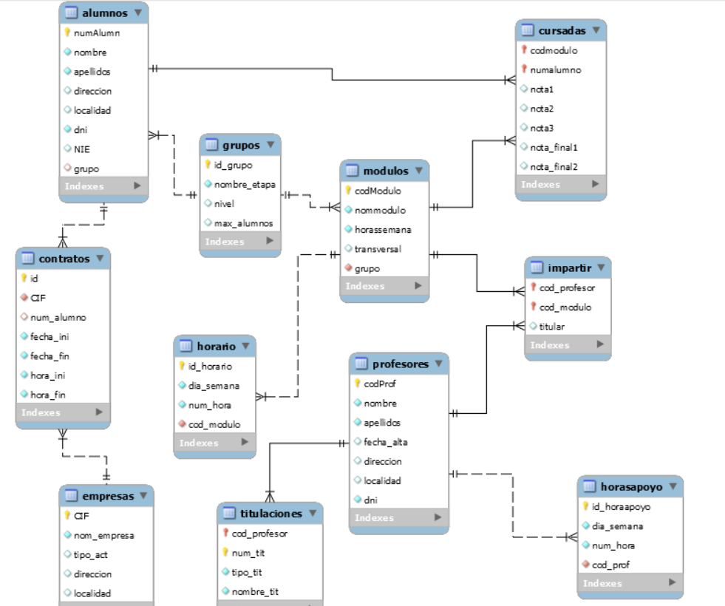

This relational diagram corresponds to the following functionality description:

* The STUDENTS table contains information about all current students at the school.
* The MODULES table contains information on all the modules taught at the center. That a module is transversal means that it has contents that are developed in training cycles of various professional families, for example, FOL would be. Each module in each cycle will have a row in the modules table, even if it has the same name. For example, the Databases module would have two rows, one for its membership in DAM and another for its membership in DAW.
* In the GROUPS table, you have information about all the groups in the center. The name of the stage is the name of the training cycle. The level is the course of the training cycle, 1 or 2 depending on whether it is first or second.
* For each student there is the group in which they are enrolled. If the code of a group is modified, this code will be modified in the students who belong to the group.
* The table COURSES contains information about the modules in which each student is enrolled.
* The SCHEDULE table contains several rows for each module, each of which indicates the day of the week and the time of day in which it is taught. The hours indicate whether it is the first, the second, etc.
* The TEACHERS table contains information about all teachers teaching in the current course. For each teacher there are the qualifications they have in the QUALIFICATIONS table. In the Teach table there is information about the modules taught by each teacher and in each case whether they are a support teacher or a full teacher. When a teacher is a support teacher, their schedule for support hours is shown in the SUPPORTHOURS table.
* The COMPANIES table contains information on all the companies with which the center has or has had agreements to carry out FCT. In the CONTRACTS table, it is recorded in which companies the students take the FCT module. The design of this table does not include the relation of foreign key with respect to the STUDENTS table nor the training cycle to which the FCT module carried out by the student belongs (this will be solved in a following activity).

Make a connection to the MySQL server using the **mysql program** and perform the following tasks using the necessary SQL statements.

1.- Create a new CENTRO database **.**

**CREATE DATABASE CENTER;**

2.- Activate or open the CENTRO database **.**

**USE CENTER;**

3.- Create a **STUDENTS table** with the columns: **student number** (integer occupying three figures, unsigned, filled with zeros and autoincremented), **name, surname, address, ID** . Set restrictions: student number is primary key; name, surname, ID are not null, and ID does not allow repeated values. Do not add the column that is a foreign key.

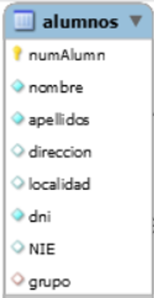

**CREATE TABLE students (**

**numalumn INT(3) UNSIGNED ZEROFILL NOT NULL AUTO_INCREMENT,**

**name VARCHAR(15) NOT NULL,**

**surnames VARCHAR(25) NOT NULL,**

**address VARCHAR(40),**

**dni CHAR(9) NOT NULL,**

**PRIMARY KEY(numalumn),**

**UNIque(dni)) ;**

4.- Create a new table called **MODULES** with the columns module code (6 letters), module name, weekly hours of the module, and a column that indicates whether or not the module is transversal and that takes the value false by default. Module code is primary key. Do not add the column that is a foreign key.

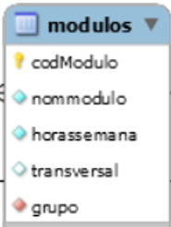

**CREATE TABLE modules (**

**codemodule CHAR(6) not null,**

**nommodule VARCHAR(80),**

**hoursweek TINYINT NOT NULL,**

**traversal BOOLEAN DEFAULT false,**

**PRIMARY KEY(modulecode));**

5.- Create a new **TEACHERS table** that contains the columns: teacher code is an unsigned and autoincremented integer, name, surname, registration date, ID, address, location. Establish the restrictions that you think are necessary according to what is represented in the design.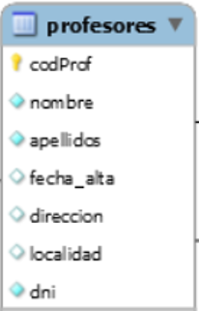

**CREATE TABLE teachers (**

**codprof INT UNSIGNED NOT NULL AUTO_INCREMENT,**

**name VARCHAR(15) NOT NULL,**

**surnames VARCHAR(25) NOT NULL,**

**high_date DATE,**

**address VARCHAR(40) ,**

**locality VARCHAR(20),**

**dni CHAR(9) NOT NULL,**

**PRIMARY KEY(profcod),**

**UNIque(dni));**

6.- Create a new **COMPANIES table** that contains the CIF, company name, type of activity, address, location. CIF is primary key. Establish the restrictions that you think are necessary according to what is represented in the design.

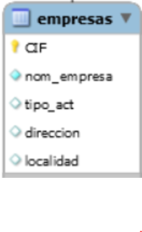

**CREATE TABLE companies (**

**cif CHAR(9) NOT NULL,**

**company_name VARCHAR(40) NOT NULL,**

**act_type VARCHAR(20),**

**address VARCHAR(40),**

**locality VARCHAR(20),**

**PRIMARY KEY(cif));**